
electromaze
Project Report

Haren pathi
George Xu

Project Aim:
The purpose this project is to create a game that is derived from the original Pacman game which is best suited for the client’s 12-year-old daughter. Java Programming Language will be used to develop the game. The objective is to create a user-friendly Java application by taking inputs from the user and to ensure the system responds. Our client has provided a set of minimum requirements which are mandatory; therefore, we are required create and develop a game like Pacman with the inclusion of our own ideas.

Game Introduction:
From the original Pacman game, the game we have created is Electromaze. The objective of this game is to navigate electroman inside an electronic maze evading all static enemies and to turn on all transceivers during his quest to find electrogirl who is lost in the world of electronics. During the game, there will be certain restrictions for both electroman and static to enhance gameplay and provide a challenge in the later stages of the game. Electroman will have a time limit of two minutes to navigate through the maze.

Requirements:
As mentioned by the client, the project brief described the minimum requirements for the game. The following set of requirements were implemented in a way that it best suits the needs of the game designed. These requirements consist of:
- A user-friendly home screen is implemented in which the user can interact with. This will allow the user to explore through the different modes whether it is to play in either single or multiplayer modes. For instance, single player mode shall incorporate one character controlled by a human against four enemies controlled by Artificial Intelligence (AI). In addition, a local multiplayer will incorporate one character and either one or two enemies controlled by humans with the remaining enemies controlled by AI.

- Before the game commences, our characters and enemies will be positioned accordingly until the countdown timer starting with three seconds remaining is reached.

- Once the timer completes three seconds prior to the game, the enemies controlled by AI and characters controlled by keyboard events shall move accordingly.

- An ideal window size is set to be at a minimum of 1024x768.

- When the player collides with the transceiver, the transceiver which is initially turned off will turn on. Each time the player turns on the transceiver, a score will be added. In addition to the scoring system of turning transceivers, the player will receive an additional bonus to their score depending on the amount of time remaining in the game.

- Both the player and enemies when colliding with walls are not able to move through them.

- When the player collides with the enemy, the game will end at this point and a notification will appear on the screen highlighting the score achieved by the user.

- The maximum time allowed for the player to complete the game (or level) is two minutes. There will be feature on the screen which will display the time remaining in the game as it counts down from two minutes.

- As the game is being played, the key ‘p’ when pressed will pause the game at that moment and until pressed again which will resume the game. If the user presses the key ‘Esc’ then the game will exit out and returns to the home screen.

- Once the protagonist turns on all transceivers without colliding with the enemies, the game will respond accordingly with a pop-up notification on the screen. This will end the game and allow the user to select either a new level or different mode.

- Sound effects in the game shall occur throughout the game depending on certain actions and collisions.

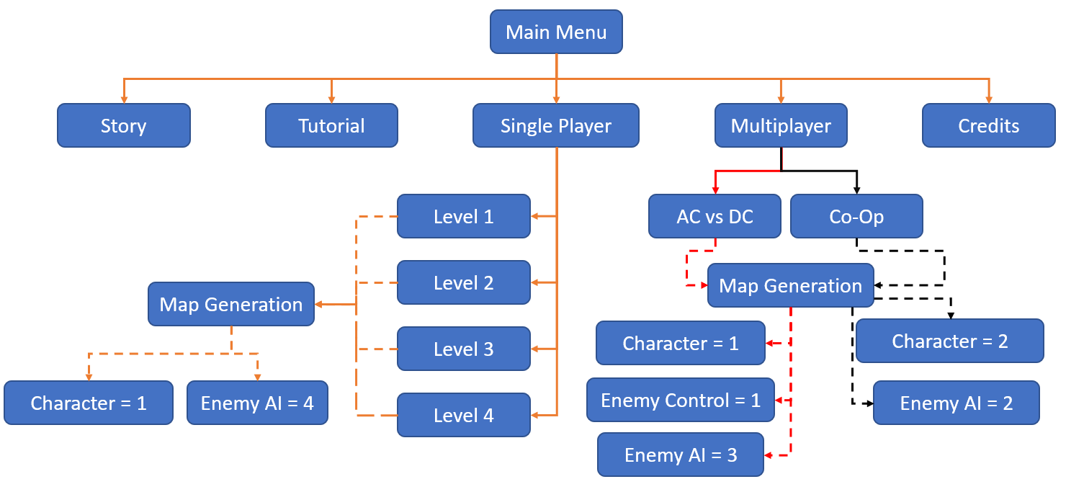
System Top Level View:
The system here has been designed to be user-friendly when a person interacts with the game. This model displays all the key features that is presented on the main menu and solid line connections highlights what the user can interact with. It the dash line highlights how each game mode consisting of single player mode and both multiplayer modes are generated. Once this process has begun, the game is all set and ready to play.

Issues/Challenges Encountered:
Through the stage of developing the game, there were certain issues that required to be addressed within the group before resolving these issues.
A significant issue we encountered during game development was that of collision detection with the walls for the protagonist once extra map features was implemented such as the impedance component. This was an issue as it required us to spend a lot more time trying to fix this bug since the enemy AI implementation was dependant on this feature to work. When we had initially thought the problem was fixed, another problem related to collision detection would occur such as the player would move further outside the wall boundaries or prevent the player from moving in two different directions after passing through the impedance component. To help understand the problem, we watched through different YouTube videos and approached the teaching assistants. As a result, we were able to overcome the problem by implementing a check to detect collisions for each corner of the image provided the key event generated. Although the player does not move outside the walls, it provided another small problem of the player struggling to move through intersections around the map. The possible solution which fixed all problems was to reduce the size of image for both player and enemies. This was advantageous as it improved player controls and ensured the game was running smoothly.

Features that improve functionality of the system:
Throughout the development of the game, there were certain features which were incorporated to highlight the uniqueness of the game from other Pacman games. Some of the features consist of:
- Maps: The maps that were designed are derived from proper electrical circuits which best suit the theme of electronics. In these map designs, they will consist of electrical components in which the nature of their functionality in real life circuits will be implemented on the game. These components are made of impedances, capacitors, and inductors.

- Gameplay: Overall gameplay is quiet dependant on the maps we generate for the game as the electronic components that are implemented will determine both characters and enemies’ behaviour. For instance, impedance component will reduce the speed of the protagonist whereas the enemy is not affected. Capacitor component will prevent the protagonist from passing through it, but the enemy is able to pass through it. Lastly, the inductor will allow the protagonist to pass through and prevents the enemy.

- Graphics: Visual representation of the game is based around the theme of electronics. We have implemented a high standard of graphics using the whole RGB spectrum which the Java programming language can provide.

- Home Screen: Along with the general different game modes, the home screen is user-friendly. The user will have access to a separate scene that explains the story of the game and consists of a developed tutorial guide to describe important features for the user to be aware before they are playing.

Suitability of the tools for the application:
Through the duration of this project, the tools used to develop a game were Java, Javafx (graphics), Bitbucket.
Java was the main programming language we were required to develop gameplay logic and other functional attributes for the game. It is high-level language which enforces an object-oriented programming model. Javafx is a library that is used in Java to develop the graphics for the game such as GUI. As a popular language, it is highly likely that the problem can be solved by searching up on google. This language is very similar to C++ programming in nature, with the advantage of providing a better experience of programming as it consists of many built in functions. As an object-oriented programming language, we are required to describe the features of the object once, which prevents the repetition of code. A disadvantage of java is the high consumption of RAM on the computer while it runs a game application.
Bitbucket was the main method of storing our progress safely as we could upload our progress on the project onto their server and allow our group partners to access it easily. To be able to upload continuously, we were creating multiple backups and supposedly a mistake was made, we will be able to differ back to the program functioning. A disadvantage with bitbucket though is at times we are required to “force push” onto the repository, which can overwrite all your other commits.

Discussion on OO design and how cohesion and coupling Issues were addressed:
During the game development, we ensured to follow the practices of Object-Oriented design. This requires us to describe the objects characteristics. Our objects are classified in classes requiring us to write functions to ensure that they are functional regarding their characteristic descriptions. Object-Oriented design is an advantage because it is an efficient method of programming as we will be able to reuse some functions of the program for other projects.
We were able to achieve low coupling and high cohesion in the game developed. To achieve high cohesion, we would ensure our classes were constructed in a form where the methods of those classes will focus only on the properties of the object. For low coupling, any major changes that is to occur will not damage the structure of other classes. For instance, the character class for the game was created in way it describes the key characteristic behaviour of movement and collision detection. Changes to these methods does not affect other classes and maintains functionality of the game.

Discussion of the software development methodology (e.g. IID):
Throughout the development of the game, the software methodology we adopted was Iterative and Incremental development (IID). Firstly, IID is a form of software development method in which our game continuously grows as we developed feature after feature and undertake continuous analysis, testing, and development. This is to ensure the functionality of the feature is robust and stable to incorporate all features of all their previous iterations for a partially completed system. We had incorporated this method to develop the game as the method was straight forward to follow. In this process, we would prioritise and ideally develop the easier parts of the game first. However, this was not the case provided certain requirements were to be completed for another feature to be implemented. During this process, we were continuously moving back and forth to improve the implementation of the previous feature for the current feature to operate as expected.

Suggested improvements for future development:
In the future, Electromaze can undergo substantial redevelopment to improve the game. These general ideas will be to improve overall gameplay, addition of more game features. From a developer’s perspective, it will be highly recommended to improve our knowledge on java programming as we will be able to follow and implement a design pattern such as MVC. This will allow us to achieve high cohesion and low coupling.
Additional game features to improve:
- AI: Improve the AI of the enemies by incorporating different characteristic. For instance, implement Dijkstra’s shortest path algorithm so one of the enemies will continuously follow you around the map. In addition, as they progress through the game on single player mode, adding more enemies is something to consider as it will provide a challenge.
- Characters: We can add more characters to the game and provide an option for the user to select their beloved characters.
- Leader board: With a scoring system in place currently to display your score after completing each level, a leader board will be an excellent way for the user to store their score.
- Levels/Map features: Generate more levels with different maps that still follow the theme of electronics. In these maps, add new electronic components to provide the user with a more difficult task of completing the level which will improve overall gameplay experience.
- Graphical Representation: To improve the graphical representation will provide the user a better experience when playing the game. Rather than using Java to create a game, game builder such as Unity can be used.

